Student Dropout Prediction System using Machine Learning & Power BI

By: Garima Kochale

1. Project Overview

Project Title
Student Dropout Prediction System using Machine Learning and Power BI Dashboard

Objective
The objective of this project is to identify students who are at risk of dropping out using Machine Learning techniques and visualize the insights through an interactive Power BI dashboard.
This system helps educational institutions:
- Detect high-risk students early
- Analyze important dropout factors
- Monitor student performance and participation
- Support intervention and decision-making

2. Problem Statement
Student dropout is a major challenge in educational institutions. Many students discontinue their studies due to poor academic performance, low attendance, lack of participation, financial issues, or low engagement.
Traditional methods of identifying at-risk students are often reactive and inefficient.
This project aims to build a predictive system that can:
- Predict dropout risk
- Classify students into risk categories
- Help institutions take preventive actions

3. Technologies Used
Technology | Purpose
Python | Data analysis and Machine Learning
Pandas | Data manipulation
NumPy | Numerical operations
Matplotlib | Data visualization
Seaborn | Statistical visualization
Scikit-learn | Machine Learning models
SHAP | Model explainability
Power BI | Dashboard creation
Jupyter Notebook | Development environment

4. Dataset Description
The dataset contains student-related information used to predict dropout probability.

Important Features
Feature | Description
student_id | Unique student identifier
attendance | Student attendance percentage
marks_avg | Average marks obtained
class_participation | Participation level in class
study_hours_per_day | Daily study hours
login_frequency | LMS/login frequency
risk_score | Calculated risk score
dropout_probability | Predicted dropout probability
risk_level | Student risk category
action | Suggested intervention action

5. Project Workflow
The project workflow consists of the following stages:
- Data Collection
- Data Cleaning
- Exploratory Data Analysis (EDA)
- Feature Engineering
- Machine Learning Model Building
- Model Evaluation
- SHAP Explainability
- Dashboard Development in Power BI
- Insights and Recommendations

6. Data Cleaning
The dataset was cleaned before model training.

Data Cleaning Steps
- Removed duplicate records
- Checked missing values
- Handled null values
- Converted categorical columns
- Verified data types
- Removed unnecessary columns
- Standardized column names

Example
# Remove duplicates
df = df.drop_duplicates()
# Check missing values
df.isnull().sum()

7. Exploratory Data Analysis (EDA)
EDA was performed to understand patterns and relationships within the dataset.

Key Analyses
- Risk level distribution
- Attendance vs Marks relationship
- Participation vs Dropout Rate
- Dropout probability distribution
- Student segmentation by risk

Visualizations Used
- Donut charts
- Scatter plots
- Bar charts
- Histograms
- Confusion matrix
- SHAP summary plots

8. Feature Engineering
Additional features were created to improve model performance.

Features Generated
- risk_level
- dropout_probability
- High risk student classification
- Suggested intervention actions

Risk Categories
Risk Score | Risk Level
0 - 0.25 | Low
0.25 - 0.50 | Medium
0.50 - 0.75 | Medium-High
0.75 - 1.00 | High

9. Machine Learning Model
A classification model was built to predict student dropout risk.

Model Used
Random Forest Classifier

Why Random Forest?
- Handles complex relationships
- Works well with mixed features
- Reduces overfitting
- Provides feature importance
- Good accuracy for classification tasks

Train-Test Split
from sklearn.model_selection import train_test_split
X_train, X_test, y_train, y_test = train_test_split(
X, y, test_size=0.2, random_state=42
)

Model Training
from sklearn.ensemble import RandomForestClassifier
model = RandomForestClassifier(random_state=42)
model.fit(X_train, y_train)

10. Model Evaluation
The model was evaluated using multiple performance metrics.

Evaluation Metrics
Metric | Purpose
Accuracy | Overall prediction performance
Precision | Correct positive predictions
Recall | Ability to detect actual dropouts
F1 Score | Balance between precision and recall
ROC-AUC | Overall classification capability

Confusion Matrix
The confusion matrix was used to evaluate:
- True Positives
- False Positives
- True Negatives
- False Negatives

Classification Report
from sklearn.metrics import classification_report
print(classification_report(y_test, y_pred))

11. SHAP Explainability
SHAP (SHapley Additive exPlanations) was used to explain model predictions.

Purpose of SHAP
- Understand feature importance
- Explain prediction behavior
- Improve model transparency
- Identify major dropout factors

SHAP Implementation
import shap
explainer = shap.TreeExplainer(model)
shap_values = explainer.shap_values(X_test)
shap.summary_plot(shap_values, X_test)

Key Insight
Features such as attendance, marks, participation, and study hours had strong influence on dropout prediction.

12. Power BI Dashboard
An interactive Power BI dashboard was developed for visualization and decision-making.

Dashboard Pages

Page 1: Student Risk Overview

KPIs
- Total Students
- High Risk Students
- Predicted Dropout Rate

Visuals
- Student Risk Distribution
- Dropout Rate by Participation Level
- Attendance vs Marks Analysis
- Dropout Probability Distribution
- Risk Level Slicer

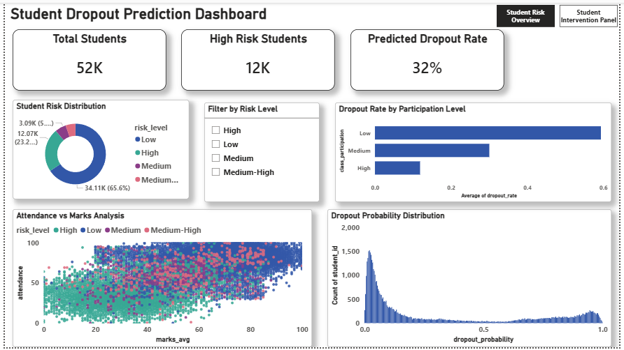

Page 2: Student Intervention Panel

Visuals
- High Risk Student List
- Risk Level Summary
- Student Intervention Table
- Risk Filters and Slicers

Dashboard Features
- Interactive filtering
- Risk segmentation
- Student-level insights
- Multi-page navigation
- Visual analytics

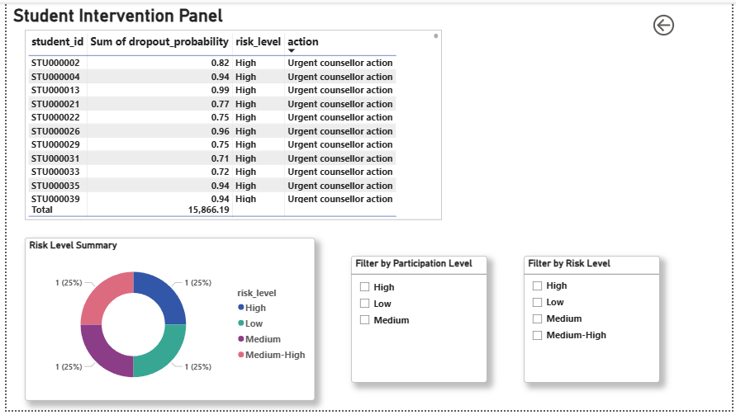

13. Key Insights
The following important insights were identified:
- Students with low attendance had higher dropout probability.
- Low class participation strongly correlated with dropout risk.
- Students with lower marks showed higher risk levels.
- High-risk students required early intervention.
- The model successfully segmented students into risk categories.

14. Business Impact
This project can help educational institutions:
- Identify at-risk students early
- Improve retention rates
- Support academic intervention
- Reduce dropout percentage
- Improve student performance monitoring

15. Limitations
- Dataset did not contain time-based/monthly fields
- Predictions depend on dataset quality
- External socio-economic factors were not included
- Real-time deployment was not implemented

16. Future Improvements
Future enhancements can include:
- Real-time prediction system
- Streamlit web application
- Email alert system
- Deep Learning models
- Integration with student management systems
- Time-series dropout trend analysis

17. Conclusion
This project successfully developed a Machine Learning-based student dropout prediction system along with an interactive Power BI dashboard.
The model helped identify high-risk students and provided meaningful insights through visualization and explainable AI techniques.
The dashboard enables institutions to take preventive actions and support students before dropout occurs.
This project demonstrates the integration of:
- Data Analysis
- Machine Learning
- Explainable AI
- Business Intelligence
- Dashboard Development

18. References
- Scikit-learn Documentation
- SHAP Documentation
- Power BI Documentation
- Pandas Documentation
- Matplotlib Documentation
- Seaborn Documentation

